The Elizabethan Era (1558-1603): A Web Quest
English Grade 9
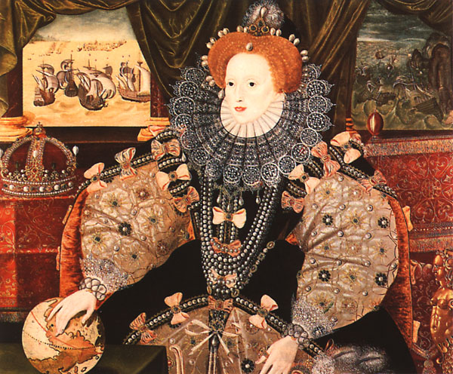

"I may not be a lion, but I am a lion's cub, and I have a lion's heart!”
- Elizabeth I, Queen of England 1558-1603

Introduction:
To fully appreciate Shakespeare’s works, it is important to learn about his life and the time period in which his works were written. This assignment requires students to investigate life during Elizabethan England (16th Century). The investigation will enable students understand the people, the places, and the events during the Shakespearean era and, in effect, provide a deeper appreciation of Shakespeare’s play Romeo and Juliet. This assignment will also help students understand how society influences literature.
As students navigate through the websites provided below, the questions included under each heading will only serve as guides – it is up to each group to gauge what material is essential and necessary to share with classmates.

Task:
Each student will be assigned to a group of at least four members. Each group will investigate a specific topic and will do a presentation to teach the rest of the class about the topic researched. The final product will be a group slideshow created via GoogleDoc’s Presentation system.

Method:
Once groups are determined, students will decide which topic below they are interested in covering. Topics can only be covered by one group each, so select a backup choice if the group’s initial selection is taken.

General Information on Elizabethan Period:
http://www.elizabethi.org/contents/

http://www.schools.ash.org.au/immanuel/htm/elizabethan.htm

http://www.britainexpress.com/History/Elizabethan_life.htm

http://www.elizabethan.org/compendium/

http://www.elizabethan-era.org.uk/index.htm

Topic A: Clothing and Appearance of the Elizabethan Period
What were the typical costumes for regular people during the Renaissance? What did the upper classes wear? What did the lower classes wear? What were the cosmetics of the era? What were hairstyles like? Are there any elements of dress from that era that are still in use today?

Elizabethan Cosmetics http://www.elizabethancostume.net/paintedface/index.html
Elizabethan Hair http://www2.springfield.k12.il.us/schools/springfield/eliz/hairstyles.html
Men's Fashion http://www2.springfield.k12.il.us/schools/springfield/eliz/mensfashion.html
Women’s http://www2.springfield.k12.il.us/schools/springfield/eliz/womensfashion.html

Elizabethan Clothing (overview) http://www.elizabethancostume.net/index.html#world

More General Information http://www.rmg.co.uk/explore/sea-and-ships/in-depth/elizabeth/the-queen's-court/body-and-dress/*/viewPage/4

Even More Information http://www.cwu.edu/~robinsos/ppages/resources/Costume_History/elizabethan.htm

Topic B: Elizabethan Health and Medicine
What were the sanitation/health conditions? What did people do when they fell ill? What were common medical treatments and medicines? What was the Bubonic Plague and how did it affect society?

http://www.elizabethan-era.org.uk/elizabethan-medicine-and-illnesses.htm

http://www.articlesbase.com/medicine-articles/medicine-in-elizabethan-england-485130.html

http://www.william-shakespeare.info/bubonic-black-plague-elizabethan-era.htm

http://www.learner.org/interactives/middleages/health.html

http://www.swopnet.com/engr/londonsewers/londontext1.html

Topic C: Youth, School, Entertainment, and Diversions of the Elizabethan Period
What were the forms of popular entertainment during this era? What did people do in their free time? What was a school day like for a student in the Renaissance? Who attended school in this period?

Life in the Elizabethan England. http://renaissance.duelingmodems.com/compendium/

What Every Schoolboy Knows http://scrtec.org/track/tracks/f02043.html

Children and Childhood http://scrtec.org/track/tracks/f02043.html

Schooling http://library.thinkquest.org/3588/Renaissance/Town/Education.html - anchor321628

Life of a Child http://library.thinkquest.org/3588/Renaissance/Town/Children.html

Children and Childhood http://elizabethan.org/compendium/40.html

Elizabethan fencing http://jan.ucc.nau.edu/~wew/fencing.html

Elizabethan Card Games http://jan.ucc.nau.edu/~wew/T attershall-tb/cards.html

Topic D: Food and Drink of Elizabethan Times
What are typical foods? Be sure to include meats, vegetables, and fruits. What are typical drinks? What methods are used to cook food? What methods are used to serve food? Do the common people eat the same as the wealthy? Be sure to differentiate in each of the above areas.

Elizabethan cooking:

http://www.elizabethi.org/us/food/

http://www.pbm.com/~lindahl/cariadoc/recipes_introduction.htmlfood link

http://elizabethan.org/compendium/46.html

http://renaissance.dm.net/compendium/38.html

http://www.renaissance-spell.com/Renaissance-Food.html

http://tudorhistory.org/topics/food/

http://www.the-tudors.org.uk/tudor-food-recipes.htm

Cooking for a group:
http://www.pbm.com/~lindahl/cariadoc/cooking_from_primary_sources.html

Topic E: Elizabeth I and Gender Roles in the Elizabethan Era
When did Queen Elizabeth I come into power? How long was she in power? Who was her father? Who succeeded her? What was her reign like? What was the status/role of women within this era? (Married? Single?) What jobs did women mostly do at the time?

British History. http://www.bbc.co.uk/history/historic_figures/elizabeth_i_queen.shtml

Elizabeth I, queen of England. http://www.bartleby.com/65/el/Elizbet1Eng.html

http://www.bbc.co.uk/history/historic_figures/elizabeth_i_queen.shtml

Elizabethan women. http://www.elizabethi.org/us/women/

The role of women. http://www.william-shakespeare.info/elizabethan-women.htm

http://www.bbc.co.uk/history/british/tudors/poverty_01.shtml

http://elizabethan.org/compendium/9.html

Topic F: The Elizabethan Theater
What were the various venues a play at which a play could be viewed? What was the price of admission at the theater? Who went to the theater? How long were performances?

http://www.springfield.k12.il.us/schools/Springfield/eliz/Globe.html

http://www.william-shakespeare.info/william-shakespeare-globe-theatre.htm

http://www.shakespearesglobe.com/about-us/history-of-the-globe

http://www.shakespeareinamericancommunities.org/education/elizabethan-theater

http://www.globe-theatre.org.uk/elizabethan-theatre.htm

Costumes/Sets in Shakespearean Theatre. http://www.springfield.k12.il.us/schools/Springfield/eliz/costumes.html

